GMORNING TEAM!  
Kaya natin to, lets not hesitate

Lets still create a work management app

BUT - lets incorporate the element of play into it - structure our tools such that working seems like playing a game (sa Nokia, they do stuff like theyre fighting a war - may tribes, may military strategy kuno)

So tasks are like levels - na-a-unlock isa isa

May stats bawat employee

May leaderboard  
May rewards

Like a create your own adventure type of thing

Everything you’d see in a typical RPG

Sa ngayon, this user story still fits that

What do you guys think?

In order for telecommuters to still have a strong sense of community, our platform should foster a workplace of collaboration working under the principle of “divide-and-conquer”

Make an app that personalizes work - a one-stop shop for work-life balance

UPDATED USER STORIES (a mash-up of off-the-shelf work management tools retrofit to the needs of govt agencies)

Against bureaucracy: <https://www.sap.com/assetdetail/2018/02/b455d411-f27c-0010-82c7-eda71af511fa.html>

Assumption 1: Users are currently employed as govt employees

Assumption 2: All transactions are paperless - all data are digitized and stored in the cloud (blockchain) - remove redundancy when filling out forms by automatically updating fields that change annually, etc

As a supervisor

* Be able to view all the list of tasks for each project/sprint
* Be able to assign tasks to employees (drag-and-drop)
* Be able to assign routine tasks in bulk
* Be able to generate charts and diagrams for analytics, eg. to be used in evaluating the employee’s output or performance

As an employee

*working from home

* I can log on the app using my User ID, government email(I made this username), or ID number and password any time of the day or week
* I can browse different tasks in my dash board with fixed priorities – I have to finish first my priority tasks before I can proceed to other tasks. Tasks in the dashboards are presented with deadlines and how many days and hours to finish it
* Be able to monitor the move of one task from one Kanban column to another (backlog - in prog - built - validated)
  + When the task is assigned to an employee, its added straight to the backlog
  + Once the employee accesses the task details, the task is moved to In Progress board
  + Once the employee submits the processed doc, the task is moved to Built board
  + Once the employer validates the submitted doc, the task is moved to Validated board
* Note that the system is the one automatically moving the tasks from one board to another

May you please enumerate the data under the Task entity; thanky

Task Description - Deadline - Priority (High/Medium/Low) - Status

(Backlog/In-Process/Built/Validated)

* Be able to categorize my tasks into Backlog - In Progress - Built - Validated
* Be able to monitor in realtime my level of efficiency (visually) - Very Inefficient (red), Average (orange), Very Efficient (Green) so I can gauge whether I’m supposed to increase/decrease the rate at which I accomplish my tasks - by comparing the expected time to deliver task/expected rate in accomplishing task vs time elapsed/actual rate doing the task
* Be able to go to my profile and see my past performance in terms of efficiency (average level of efficiency, total number of backlog, in progress, build and validated) and output accuracy (total number of docs validated at once over the total number of docs I processed)
* I can submit my tasks through the system for checking of my supervisor. I cannot submit beyond deadline unless approved by my supervisor. Every late job submitted shall merit a written explanation and a deduction on my evaluation
* I can be notified through the mobile app and SMS of the corrections/additions (ENHANCEMENT) in my submitted work and how urgently to modify them

What value will represent the HOW URGENT the ENHANCEMENT is (same as priority points? Okay)

* I can be notified through the mobile app and SMS if my submitted work is approved, and if there are other tasks I have to do and the days/hours I need to finish them – e.g. Financial Statements for the month, due: November 30, 3 days 2 hours. My approved works shall be stored in the app’s database and can be accessed by other employees depending on their authorization level
* Get alerts/notification when I am about to hit the critical level of efficiency (example, when a company sets the minimum level of efficiency to 60%)
* I can open files/content (one at a time depending on the status on my dashboard/priority tasks board) that I need for my tasks and with preapproved authorization depending on my level
* Can use the chat, call, and teleconferencing feature of the app to contact immediate superiors, peers, co-workers whom I need info from. I can also access the number directories found on the dashboard
* View my profile such as my personal information, credit leaves, evaluation results, personal messages, and daily, weekly, and monthly progress on my tasks
* View the FAQ and help & support in the app’s website

*working in the field

* I can log on the app using my User ID, government email, or ID number and password on the hours I am required to report to work
* I can access various report templates I need to submit during my field work. I can fill out the forms and submit it through the app within the designated timeframe. My reports shall be sent to my supervisor and the industry that I am checking (if any)
* I will be notified through SMS and mobile app if there is a query about the reports that I submitted
* Can use the chat, call, and teleconferencing feature of the app to contact immediate superiors, peers, co-workers whom I need info from. I can also access the number directories found on the dashboard
* View my profile such as my personal information, evaluation results and personal messages

**Telecommuting Application Feature**

As an employee

* I can apply for a telecommuting privilege by being able to notify my employer of my intent to work remotely. The basis for approval of my application shall be based on my ratings in the Performance Based Incentive System (PBIS). I should meet “Best” in my PBIS rating in order for me to be considered for TPR
* Attach my credentials / make my credentials visible (performance on previous tasks and PBIS rating) on the telecommuting privilege request (TPR) in order for system/employer to determine whether I can be granted TPR.
* After being granted TPR, I have to maintain my rating in the PBIS in addition to getting “Excellent” in the quarterly evaluation of my output tbased on accuracy, timeliness and efficiency. Failure to do so would merit a verbal reprimand for the first time, written reprimand for the second time, and revocation of my TPR on the third offense. This is in addition to whatever administrative sanctions are applicable to such offense.

As a PWD employee

* Be able to create an account and verify account by submitting PWD docs
* Be exempt from TPR and get the telecommuting privilege automatically

As an employer

* Get alerts/notification when an employee hits a critical level of efficiency (example, when a company sets the minimum level of efficiency to 60%)
* Be able to view the daily Kanban diagram of work of my employees to see which employee is stuck on a certain stage (identify bottleneck)
* 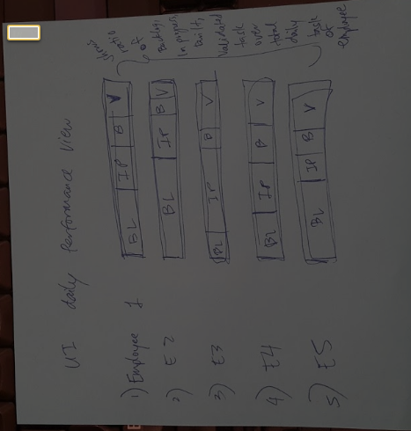
* Hovering over the employees name, and Kanban blocks will show quick statistics/summary
* 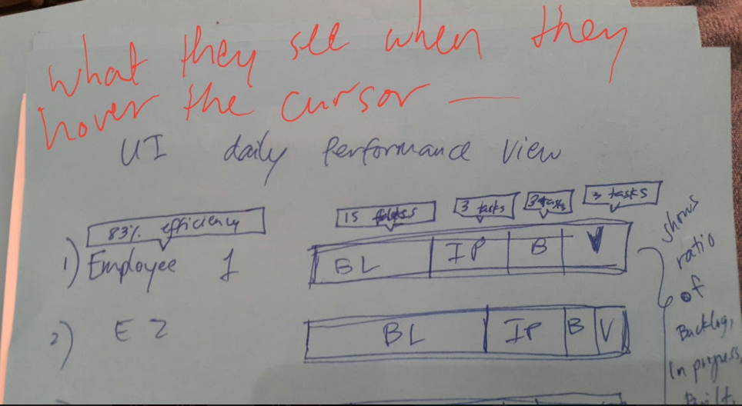
* Be able to view the monthly Kanban diagram summary/average/statistics/report of my employees to see which among them might need additional training/support
* Be able to click on an employee’s name and see a more detailed report on their Kanban progress diagram (with the list of tasks on each Kanban column instead of a total number only) and average level of efficiency during the month (average level of efficiency, total number of backlog, in progress, built and validated) with an option to sort by the employees in terms of (a) level of efficiency, (b) total # of backlog, (c) total # of in progress, (d) built and (e) validated tasks

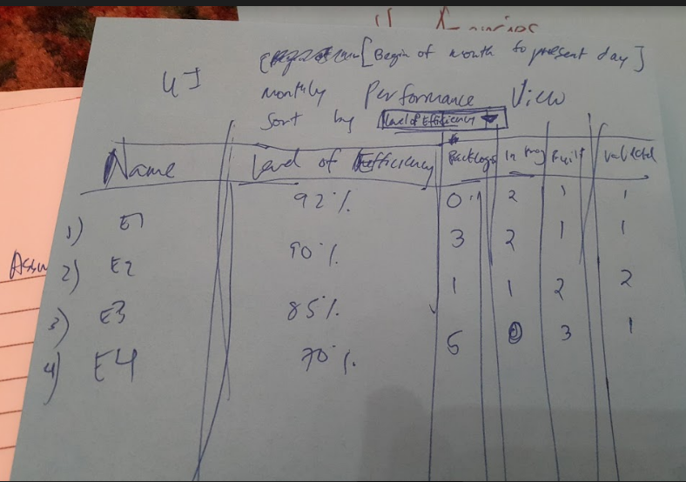

* Be able to view employee-rating according to a certain set of parameters/evaluation metrics - as evaluated by both client and industry; Rating is verified when client & industry score have minimal discrepancy. Otherwise, rating is treated as an outlier and discarded/unaccounted for